New Escrow Analysis Page in Online Accounts (ACP)
CALL CENTER ALERT (CCA)
Audience: All

Effective immediately
The Escrow Analysis page on Freedom’s web portal (ACP)
has been re-designed to help more customers self-serve.

- The new design is being rolled out to a small percentage of customers, before expanding to all customers in early February.
- If a customer describes a layout you don’t recognize, they may be seeing the new design.

This affects online web portal accounts only. The mobile app is not affected.

New Design Features
- Simplified layout: One-page design, less scrolling
- Payment change explanation: Clear breakdown of why payment is changing, shown at top
- Escrow Analysis Result Card: New section showing shortage, surplus, or balanced status at-a-glance
- Expanded FAQs: Common questions answered directly on the page
- Escrow Statement access: More prominently featured

What’s NOT Changing
- Mobile app: The mobile app will continue to show the existing escrow design for now
- Escrow calculations: No changes to how escrow is calculated or applied
- Payment options: Same shortage payment options
- Escrow Statement: Same PDF document, now easier to access

Key Areas
❶ Summary section (top) — shows current vs. new payment
❷ Payment change explanation — why the payment changed.
  - Top Customer Question: Why did my payment go up?
❸ Escrow Analysis Results – displays shortage amount, surplus refund, or balanced status depending on customer’s analysis results.
❹ FAQs — expandable section
  - Top Customer Question: Where is my Escrow Statement?
❺ Shortage payment options — same options, clearer presentation
  - Top Customer Question: How much is my shortage/surplus?
❻ Link to Matic to get quotes on homeowner insurance

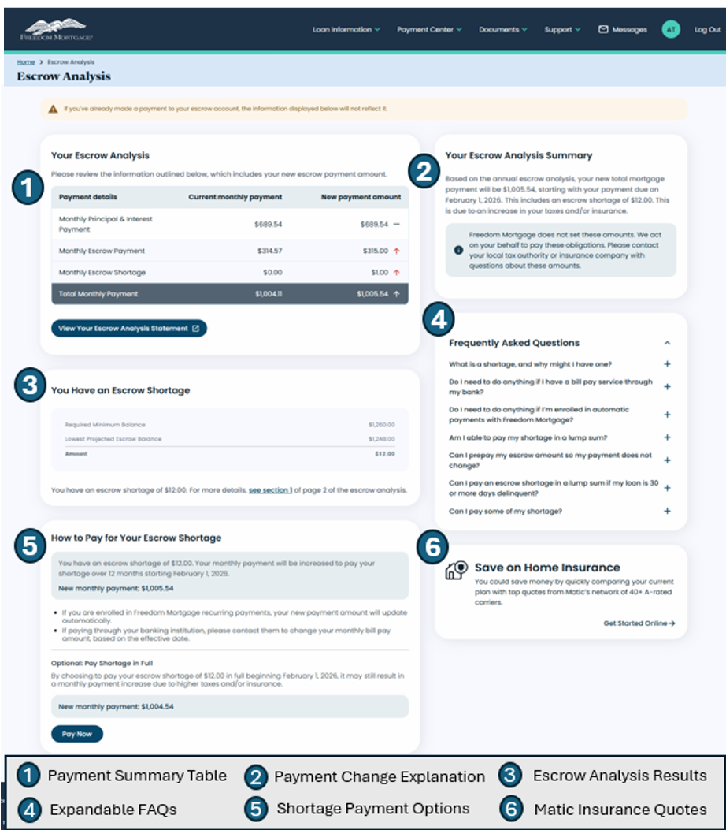
What Customers Might Say

Customer Says | How to Respond
“My escrow page looks different” | “We recently updated the design to make it easier to understand. The information and options are the same — just a cleaner layout.”
“I can’t find [X]” | Guide them to the appropriate section (see screenshot above)
“My spouse/friend sees the old design” | “We’re rolling this out gradually, so some customers may still see the previous design temporarily.”
“Why did my payment change?” | Direct them to the payment change explanation section at the top of the page and the statement for additional details

Supervisors Only
Your feedback during the pilot is valuable — it helps us catch issues and improve the experience before full launch.
- If you hear repeated customer complaints about the new design, or notice any issues, please contact:
Tom Vivaldelli — thomasvivaldelli@freedommortgage.com

If you have questions please contact your supervisor.

